**Team Name**

TEAM UNITY 53

**Info About Game**

**Team Members**

* Enes YAZ: Product Owner / Developer
* Ayşenur TURAN: Scrum Master/ UI UX Developer
* Sena YILDIZ: Developer
* Yağız TÜRK: Developer
* Hazar KARAYAMAN: Developer

**Game Name**

--The way of Kachujin--

**Product Backlog URL**

[Unity Team 53 Trello Backlog Board](https://trello.com/invite/b/AQu1OwCJ/ATTIe6b4f87c6d59c3e73914049904d297623D346181/bootcamp-agile-project)

**Product Description**

**Storyline & Characters**

The game revolves around the escape story of a character with psychic powers and telekinesis abilities. The subjects, who have gained superpowers as a result of experiments conducted on them within the framework of a program aiming to create flawless children, are being held in custody in a rehabilitation town. The game is designed by constructing an adventure of escape from this place

* Game The game revolves focuses on the 20th century. Within the 3D designed world, movement and mechanics are shaped by 2D transitions

* Physics

World basic physics(running, jumping, walking)

Telekinesis

* Player Characters

-Kachujin( the female character has telekinesis)

Telekinesis: Your hero can manipulate objects mentally and use them against enemies.

-Professors

* The Game Objects-Rewards

Weapons

* Interface:

Interact with objects in the world

**Game Features**

Hero with Special Powers is an action-packedadventure that puts players in the shoes of a remarkable hero with extraordinary abilities.

**Key Features**

1. The goal and Unique Character: Play as a hero with a diverse set of special powers, each offering a distinct gameplay experience. Unleash your powers to overcome obstacles and defeat formidable enemies.
2. Engaging Storyline: Experience a captivating narrative that unfolds as you progress through the game. Unravel mysteries, encounter memorable characters, and make crucial choices that shape the outcome of your journey.
3. Unlock new abilities to enhance your hero's powers.Discover their weaknesses, exploit their patterns, and emerge triumphant in intense showdowns.
4. Level Design: Delight in the detailed environments, impressive special effects, and affect of light and shadows that enhances the gameplay atmosphere.

**Game Controls**

W - Jump

A - Move Left

D - Move Right

Left Mouse Button - Hold Object

Right Mouse Button - Activate special powers

E/Q-Rotate object

**Missions**

The game consists of a series of missions with varying difficulty levels. In each mission, you'll need to utilize your character's special powers to achieve specific objectives. Completing missions earns you points and unlocks further levels in the game

**Note to the jury**

Due to the extensive and large-scale nature of the levels, lack of experience, and time constraints, a flexible deadline has been set for the game design

**Target Audience**

With its action-packed gameplay and immersive storyline, the game appeals to who enjoy thrilling adventures and strategic combat.

Hero with Special Powers includes:

* Action Game Enthusiasts
* Adventure Seekers
* Fans of Superhero Stories
* Puzzle Solvers

**Sprint 1**

\***The estimated score to be completed within the sprint:** 100 Point

\***The logic of completing points/scores:** With the logic of Tshirt size

Overall, there is a backlog of 500 points that need to be completed throughout the project. When divided into 3 sprints, it was decided that the first sprint should start with at least 100 points.

\***Daily Scrum:** Due to time constraints, it has been decided to conduct Daily Scrum meetings via WhatsApp. An example of a Daily Scrum meeting is shared by us in the Readme file as a JPEG or Word document [**Sprint 1 Daily Scrum Chats**](Read%20Me/Daily%20Scrum.docx)

\***Sprint board update:** Sprint board screenshots:

Sprint Board Final

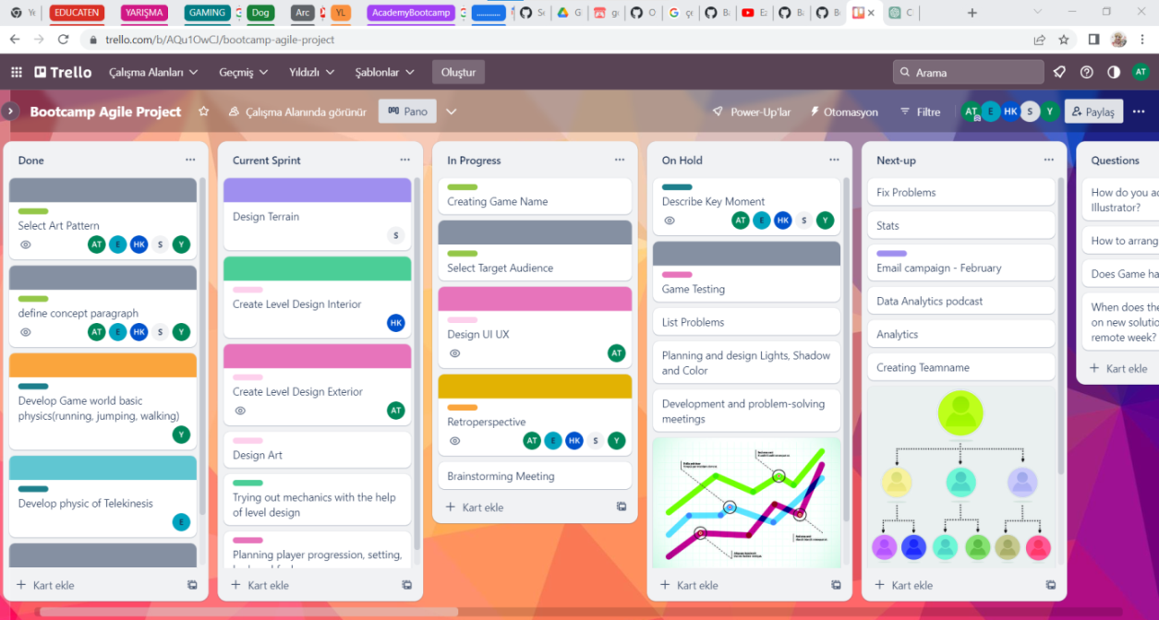

First Craft

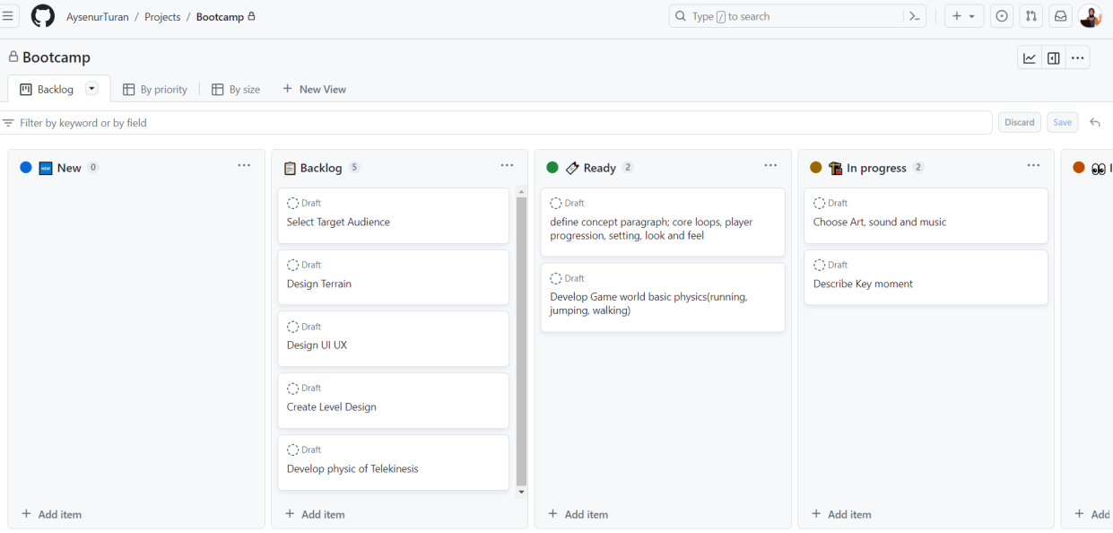

* Game Status: Screen Shots:

Stage1

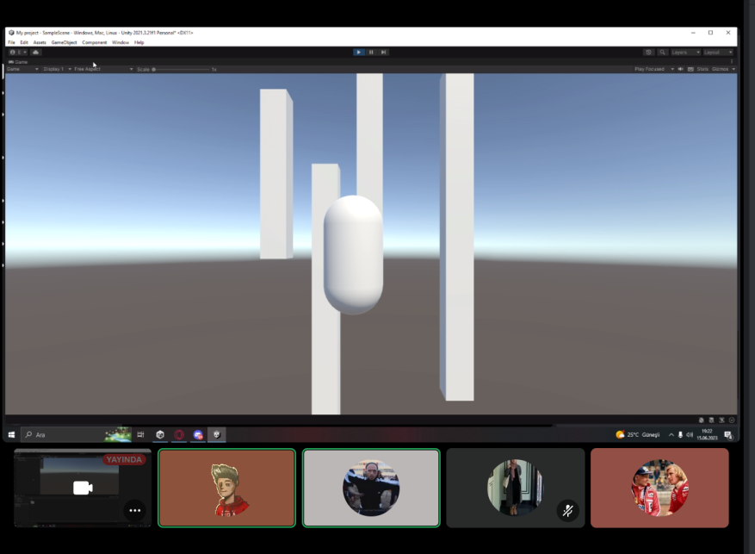

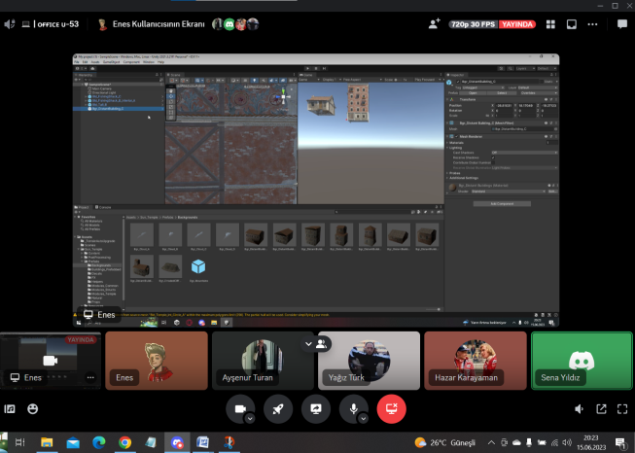 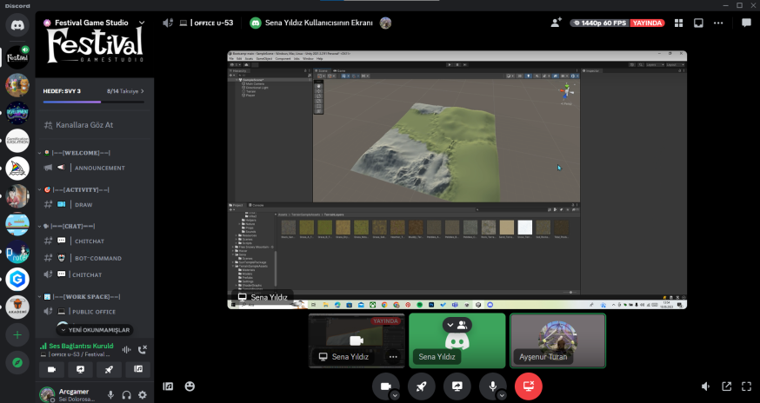

Stage 2 Stage3

* Sprint Review: General Decision: Completed selecting art pattern, defining concept paragraph, Developing Game world basic physics(running, jumping, walking),Develop physic of Telekinesis,Starting Level Design interior and Terrain

* Sprint Retrospective:

* "Task distributions have been made."
* "The clear distinction between roles has been redefined to be more permeable."
* "The reduced activity of team members due to their ongoing exams will be eliminated in the upcoming sprints, allowing the project to progress faster and reach its full potential."

**Product Backlog URL**

https://trello.com/b/AQu1OwCJ/bootcamp-agile-project